|  |  |  |
| --- | --- | --- |
| **We worked on our sections independently and merged them once we finished** | | |
| **Name** | **Date** | **Description** |
| Matthew | 11/17/17 | Sections 1.1-1.4 and 2.1-2.2 |
| Erik | 11/18/17 | Sections 4.1 and 4.2 |
| Brandon | 11/18/17 | Sections 3.1 and 3.2 |
| Joseph | 11/19/17 | Sections 3.3 and 3.4 |
| Evan | 11/19/17 | Section 4.3 |
| Kyle | 11/20/17 | Sections 2.3 and 2.4 |

**Brand Central Station**

Senior Capstone Project

Evan Bradley

Erik Culberson

Matthew DeMott

Joseph Herkness

Brandon Jackson

Kyle Schrade

**1. Project vision**

[1.1. Backgrounds](https://docs.google.com/document/d/13HBNNTTXO7p7WvBjj4b8SiPZoUP5DzRu4Pkk3tMxYWg/edit#heading=h.p9zxzc419cvk)

[1.2. Socio-economical Impact, Business Objectives, and Gap Analysis](https://docs.google.com/document/d/13HBNNTTXO7p7WvBjj4b8SiPZoUP5DzRu4Pkk3tMxYWg/edit#heading=h.fgtdo7mrxvap)

[1.3. Security and ethical concerns](https://docs.google.com/document/d/13HBNNTTXO7p7WvBjj4b8SiPZoUP5DzRu4Pkk3tMxYWg/edit#heading=h.wvzp4zxd47lr)

[1.4. Glossary of Key Terms](https://docs.google.com/document/d/13HBNNTTXO7p7WvBjj4b8SiPZoUP5DzRu4Pkk3tMxYWg/edit#heading=h.izw42ce3c8bn)

[**2. Project Execution and Planning**](https://docs.google.com/document/d/13HBNNTTXO7p7WvBjj4b8SiPZoUP5DzRu4Pkk3tMxYWg/edit#heading=h.ejr4nndx9udt)

[2.1. Team Information](https://docs.google.com/document/d/13HBNNTTXO7p7WvBjj4b8SiPZoUP5DzRu4Pkk3tMxYWg/edit#heading=h.uuqqvu79wf44)

[2.2. Tools and Technology](https://docs.google.com/document/d/13HBNNTTXO7p7WvBjj4b8SiPZoUP5DzRu4Pkk3tMxYWg/edit#heading=h.pbvtbks6uf1y)

[2.3. Project Plan](https://docs.google.com/document/d/13HBNNTTXO7p7WvBjj4b8SiPZoUP5DzRu4Pkk3tMxYWg/edit#heading=h.gfoid56g6cvi)

[2.4. Best standards and Practices](https://docs.google.com/document/d/13HBNNTTXO7p7WvBjj4b8SiPZoUP5DzRu4Pkk3tMxYWg/edit#heading=h.yqd6e59r3vrn)

[**3. System Requirement Analysis**](https://docs.google.com/document/d/13HBNNTTXO7p7WvBjj4b8SiPZoUP5DzRu4Pkk3tMxYWg/edit#heading=h.asw7hrd3zwmm)

[3.1. Function Requirements](https://docs.google.com/document/d/13HBNNTTXO7p7WvBjj4b8SiPZoUP5DzRu4Pkk3tMxYWg/edit#heading=h.5pta7ntgu6vn)

[3.2. Non-functional Requirements](https://docs.google.com/document/d/13HBNNTTXO7p7WvBjj4b8SiPZoUP5DzRu4Pkk3tMxYWg/edit#heading=h.ad3kg9bplvuk)

[3.3. On-Screen Appearance of landing and other pages requirements.](https://docs.google.com/document/d/13HBNNTTXO7p7WvBjj4b8SiPZoUP5DzRu4Pkk3tMxYWg/edit#heading=h.fsccfi17h2vh)

[3.4. Wireframe designs](https://docs.google.com/document/d/13HBNNTTXO7p7WvBjj4b8SiPZoUP5DzRu4Pkk3tMxYWg/edit#heading=h.2i6gnjzfrhr2)

[**4. Functional Requirements Specification**](https://docs.google.com/document/d/13HBNNTTXO7p7WvBjj4b8SiPZoUP5DzRu4Pkk3tMxYWg/edit#heading=h.8j37t0v0c9bj)

[4.1. Stakeholders](https://docs.google.com/document/d/13HBNNTTXO7p7WvBjj4b8SiPZoUP5DzRu4Pkk3tMxYWg/edit#heading=h.fwju5mtl8tf7)

[4.2. Actors and Goals](https://docs.google.com/document/d/13HBNNTTXO7p7WvBjj4b8SiPZoUP5DzRu4Pkk3tMxYWg/edit#heading=h.28eaxj2e904)

[4.3. User stories, scenarios and Use Cases](https://docs.google.com/document/d/13HBNNTTXO7p7WvBjj4b8SiPZoUP5DzRu4Pkk3tMxYWg/edit#heading=h.c6xmdd569moi)

[4.4. System Sequence / Activity Diagrams](https://docs.google.com/document/d/13HBNNTTXO7p7WvBjj4b8SiPZoUP5DzRu4Pkk3tMxYWg/edit#heading=h.a1gj6r91f5vb)

[**5. User Interface Specifications**](https://docs.google.com/document/d/13HBNNTTXO7p7WvBjj4b8SiPZoUP5DzRu4Pkk3tMxYWg/edit#heading=h.naloi9p1rjyt)

[5.1. Preliminary Design](https://docs.google.com/document/d/13HBNNTTXO7p7WvBjj4b8SiPZoUP5DzRu4Pkk3tMxYWg/edit#heading=h.wh4mzdsu3xyp)

[5.2. User Effort Estimation](https://docs.google.com/document/d/13HBNNTTXO7p7WvBjj4b8SiPZoUP5DzRu4Pkk3tMxYWg/edit#heading=h.duetwjr0vbuo)

[**6. Static Design**](https://docs.google.com/document/d/13HBNNTTXO7p7WvBjj4b8SiPZoUP5DzRu4Pkk3tMxYWg/edit#heading=h.pcd12zl1chs)

[6.1. Class Model](https://docs.google.com/document/d/13HBNNTTXO7p7WvBjj4b8SiPZoUP5DzRu4Pkk3tMxYWg/edit#heading=h.48rpqspbnxlr)

[6.2. System Operation Contracts](https://docs.google.com/document/d/13HBNNTTXO7p7WvBjj4b8SiPZoUP5DzRu4Pkk3tMxYWg/edit#heading=h.p7budr91q9at)

[6.3. Mathematical Model](https://docs.google.com/document/d/13HBNNTTXO7p7WvBjj4b8SiPZoUP5DzRu4Pkk3tMxYWg/edit#heading=h.nn2wyk2uei2m)

[6.4. Entity Relation](https://docs.google.com/document/d/13HBNNTTXO7p7WvBjj4b8SiPZoUP5DzRu4Pkk3tMxYWg/edit#heading=h.do5lto9xlgla)

[**7. Dynamic Design**](https://docs.google.com/document/d/13HBNNTTXO7p7WvBjj4b8SiPZoUP5DzRu4Pkk3tMxYWg/edit#heading=h.9bwv7y9e97so)

[7.1. Sequence Diagrams.](https://docs.google.com/document/d/13HBNNTTXO7p7WvBjj4b8SiPZoUP5DzRu4Pkk3tMxYWg/edit#heading=h.g12xagxo3fbe)

[7.2. Interface Specification](https://docs.google.com/document/d/13HBNNTTXO7p7WvBjj4b8SiPZoUP5DzRu4Pkk3tMxYWg/edit#heading=h.oafesl6omle5)

[7.3. State Diagrams](https://docs.google.com/document/d/13HBNNTTXO7p7WvBjj4b8SiPZoUP5DzRu4Pkk3tMxYWg/edit#heading=h.iysjbrpk40i8)

[**8. System Architecture and System Design**](https://docs.google.com/document/d/13HBNNTTXO7p7WvBjj4b8SiPZoUP5DzRu4Pkk3tMxYWg/edit#heading=h.bb9ud05xv2rm)

[8.1. Subsystems / Component / Design Pattern Identification](https://docs.google.com/document/d/13HBNNTTXO7p7WvBjj4b8SiPZoUP5DzRu4Pkk3tMxYWg/edit#heading=h.bmhhas97gx8c)

[8.2. Mapping Subsystems to Hardware (Deployment Diagram)](https://docs.google.com/document/d/13HBNNTTXO7p7WvBjj4b8SiPZoUP5DzRu4Pkk3tMxYWg/edit#heading=h.5gz5cc10jwls)

[8.3. Persistent Data Storage](https://docs.google.com/document/d/13HBNNTTXO7p7WvBjj4b8SiPZoUP5DzRu4Pkk3tMxYWg/edit#heading=h.4gkfresayxhp)

[8.4. Network Protocol](https://docs.google.com/document/d/13HBNNTTXO7p7WvBjj4b8SiPZoUP5DzRu4Pkk3tMxYWg/edit#heading=h.r0ia3vd2h0cu)

[8.5. Global Control Flow](https://docs.google.com/document/d/13HBNNTTXO7p7WvBjj4b8SiPZoUP5DzRu4Pkk3tMxYWg/edit#heading=h.tue47e555ean)

[8.6. Hardware Requirement](https://docs.google.com/document/d/13HBNNTTXO7p7WvBjj4b8SiPZoUP5DzRu4Pkk3tMxYWg/edit#heading=h.eqifj9vtf05s)

[**9. Algorithms and Data Structures**](https://docs.google.com/document/d/13HBNNTTXO7p7WvBjj4b8SiPZoUP5DzRu4Pkk3tMxYWg/edit#heading=h.d5jg5uooqwt)

[9.1. Algorithms](https://docs.google.com/document/d/13HBNNTTXO7p7WvBjj4b8SiPZoUP5DzRu4Pkk3tMxYWg/edit#heading=h.mk7qfbtd145s)

[9.2. Data Structures](https://docs.google.com/document/d/13HBNNTTXO7p7WvBjj4b8SiPZoUP5DzRu4Pkk3tMxYWg/edit#heading=h.v3x086qyiaoa)

[**10. User Interface Design and Implementation**](https://docs.google.com/document/d/13HBNNTTXO7p7WvBjj4b8SiPZoUP5DzRu4Pkk3tMxYWg/edit#heading=h.tay8bd17v9su)

[10.1. User Interface Design](https://docs.google.com/document/d/13HBNNTTXO7p7WvBjj4b8SiPZoUP5DzRu4Pkk3tMxYWg/edit#heading=h.zfssb918cyr3)

[10.2. User Interface Implementation](https://docs.google.com/document/d/13HBNNTTXO7p7WvBjj4b8SiPZoUP5DzRu4Pkk3tMxYWg/edit#heading=h.6g5djri1rcmm)

[**11. Testing**](https://docs.google.com/document/d/13HBNNTTXO7p7WvBjj4b8SiPZoUP5DzRu4Pkk3tMxYWg/edit#heading=h.342gqb8sw5ll)

[11.1. Unit Test Architecture and Strategy/Framework](https://docs.google.com/document/d/13HBNNTTXO7p7WvBjj4b8SiPZoUP5DzRu4Pkk3tMxYWg/edit#heading=h.ispihau0hv3)

[11.2. Unit test definition, test data selection](https://docs.google.com/document/d/13HBNNTTXO7p7WvBjj4b8SiPZoUP5DzRu4Pkk3tMxYWg/edit#heading=h.85bx1je6fhum)

[11.3. System Test Specification](https://docs.google.com/document/d/13HBNNTTXO7p7WvBjj4b8SiPZoUP5DzRu4Pkk3tMxYWg/edit#heading=h.ssq838aftfh2)

[11.4. Test Reports per Spring](https://docs.google.com/document/d/13HBNNTTXO7p7WvBjj4b8SiPZoUP5DzRu4Pkk3tMxYWg/edit#heading=h.mb548rjm12kp)

[**12. Project Management**](https://docs.google.com/document/d/13HBNNTTXO7p7WvBjj4b8SiPZoUP5DzRu4Pkk3tMxYWg/edit#heading=h.aaxuaeye72du)

[12.1. 11.1 Project Plan](https://docs.google.com/document/d/13HBNNTTXO7p7WvBjj4b8SiPZoUP5DzRu4Pkk3tMxYWg/edit#heading=h.5lx9xop45037)

[12.2. 11.2 Risk management](https://docs.google.com/document/d/13HBNNTTXO7p7WvBjj4b8SiPZoUP5DzRu4Pkk3tMxYWg/edit#heading=h.cbrmwgvnyvki)

[**13. References**](https://docs.google.com/document/d/13HBNNTTXO7p7WvBjj4b8SiPZoUP5DzRu4Pkk3tMxYWg/edit#heading=h.oqjfgp8wm8pa)

1. **Project vision** 
   1. **Backgrounds**
      1. Searching for a general type of product, but don’t know exactly what you want? Everyone has experienced a situation similar to this. You want something new, however you do not know where to look. This leaves two general solutions, drive around from store to store looking or shop online. Driving around wastes time and gas while combing through website after website can be cumbersome with little results. This is the problem that brand central will solve. We will assemble a large set of products in one location for users to browse through. As the users browse, they will give the application input on whether they like or dislike the products that are being presented to them. Through this input, our algorithm with create user models to actively learn what products would be fit the user’s preferences. Brand central will make it easier for users to see what they want without the hassle of digging through countless website or driving to store after store. Not only will our website do the dirty work for the user, but there will be many different types of products and brands all in one central location.
      2. While this idea solves a problem for users, it also is a good solution for businesses. We are providing a great way to advertise products in a far less annoying fashion. Not only will advertising be less annoying, it will also be a more effective way to advertise. With the user models, our website will know what users will be more likely to prefer, thus allowing businesses to pinpoint which users will like their products.
   2. **Socio-economical Impact, Business Objectives, and Gap Analysis** 
      1. **Socio-economic Impact**
         1. As many experts expect in store retailers to be less favorable to shoppers, one can expect this to be a point of focus for our application. We expect that our application will focus on this target market. As this market increases, we expect our solution to be keeping for a sizeable market share. Shoppers will no longer have to interact with the in store experience or the conventional online experience. They can head to our website and interact with our seamless user interface. We will be pulling mostly from the online market, however we would be aiming to pull some of the in store market as well.
      2. **Business Objectives**
         1. Our application has the business goal based on retail sales and advertising. Retailers spend millions of dollars each year on trying to advertise their products. On the other hand, users of applications or viewers find these advertisements to be annoying and bothersome. Therefore, we believe that our application is a much better way to advertise products. Users will be going to our application to see products in a fun way. Not only will this be a less annoying way to advertise, but a much more effective way to communicate advertisers’ messages. Our application will be using real time input from users on what they prefer to see. This allows for a matchmaking service for users and products. Therefore, the user will be much more likely to purchase the products they see than if the business advertised on another platform.
         2. We are also planning on implementing a royalty program. Once we implement the buy function within our application, we will take a small fee, similar to a finders fee. We would charge the seller of the product for helping sell the product. We would most likely implement this once our product got more popular. We would not want to implement this early on because our service would not warrant the fee at that time.
      3. **Gap Analysis**
         1. In analysis of the retail market, our group realized that in store retail is on its way out while e-commerce is on its way up. Therefore, when looking at the online shopping experience, we noticed that finding products can be somewhat cumbersome. Not only can finding products be time consuming, we observed that knowing where to look to find new products to be less intuitive than it should be. Other services allow for users to search for products, but no services provide a solution that suggests products to users without the purchase of multiple products. In addition, no solution customizes product suggestions to users based on their preferences that they continually input. We believed that our application would fill this gap.
   3. **Security and ethical concerns**
      1. The first security issue that comes into consideration is user data. Our application will be collecting user information such as their name, email, password, but most importantly their preferences. In the background section we discussed how we can customize our application to the user’s preferences, however this can be a sensitive subject. Within our application using this data is generally okay, but if we were to sell this information it can be a grey area. If the user consents to this in the terms and conditions it is considered legally okay, but this may be violating potential ethical concerns. Many users see this type of exchange as ethically not okay. Theoretically we would not be selling user data to the highest bidder due to this concern and to protect our users interest. On the security front, we would have to ensure that our users’ data would be protected from hackers who may want to sell this data to other companies to exploit.
   4. **Glossary of Key Terms**
      1. **Channel** - A channel consists of a type of product that will be a general theme for most types of products that will be suggested through that channel.
      2. **Channel View** - The Channel View is where products are suggested to a Shopper based on the Shopper’s preferences/input and what type of channel the Shopper is looking at. In the Channel View, Shoppers can like/dislike/skip products they are being presented.
      3. **Liked Products Page** - Is a page associated with a Shopper that has all the products the Shopper has liked at any time.
      4. **Shopper** - Is a user of our website that has registered for a profile. A Shopper has the ability to edit their profile, create/delete a channel, like/dislike/skip a product, and follow other shoppers.
2. **Project Execution and Planning** 
   1. **Team Information**
      1. Erik
         1. Machine Learning, Server Admin
      2. Evan
         1. Back End, Server Admin, Machine Learning, Testing Back End
      3. Brandon
         1. Database, Machine Learning, Data Collection
      4. Joseph
         1. Front End, API Setup, Github Manager
      5. Kyle
         1. Front End, Mobile App
      6. Matthew
         1. Documentation, Back End, Project Management
   2. **Tools and Technology**

|  |  |
| --- | --- |
| Tool Name | Application |
| Node.js | Server |
| Vue.js | Web Application |
| MySQL | Database |
| Javascript/Python | Data Scraping |
| Github | Version Control |
| Google Drive | Documentation |
| Slack & Discord | Communication |
| Ubuntu Server | Server |

* 1. **Project Plan**

|  |  |  |  |  |
| --- | --- | --- | --- | --- |
| Item Type | Sprint Number | Name | Start | Finish |
| Sprint | 1 | Sprint #1 | Thu 9/7/17 | Wed 9/13/17 |
| Work Item | 1 | Brainstorm doc | Thu 9/7/17 | Fri 9/8/17 |
| Work Item | 1 | Functional Requirements | Mon 9/11/17 | Mon 9/11/17 |
| Work Item | 1 | Nonfunctional Requirements | Mon 9/11/17 | Mon 9/11/17 |
| Work Item | 1 | Use Cases | Mon 9/11/17 | Mon 9/11/17 |
| Work Item | 1 | Project Plan | Tue 9/12/17 | Tue 9/12/17 |
| Work Item | 1 | Set Up GitHub | Tue 9/12/17 | Tue 9/12/17 |
| Work Item | 1 | Group Meeting | Tue 9/12/17 | Tue 9/12/17 |
| Work Item | 1 | Sprint 1 powerpoint | Wed 9/13/17 | Wed 9/13/17 |
| Work Item | 1 | Risks | Mon 9/11/17 | Wed 9/13/17 |
| Sprint | 2 | Sprint #2 | Fri 9/15/17 | Wed 9/27/17 |
| Work Item | 2 | Setup API | Fri 9/15/17 | Sun 9/17/17 |
| Work Item | 2 | Register For Profile | Mon 9/18/17 | Fri 9/22/17 |
| Work Item | 2 | Email Verification | Sat 9/23/17 | Wed 9/27/17 |
| Work Item | 2 | Sign In | Mon 9/18/17 | Tue 9/19/17 |
| Work Item | 2 | Sign Out | Wed 9/20/17 | Wed 9/20/17 |
| Work Item | 2 | Design Database | Fri 9/15/17 | Sun 9/17/17 |
| Work Item | 2 | Setup Database | Mon 9/18/17 | Thu 9/21/17 |
| Work Item | 2 | Profile Page | Fri 9/22/17 | Sat 9/23/17 |
| Work Item | 2 | Edit Profile | Mon 9/25/17 | Wed 9/27/17 |
| Work Item | 2 | Sprint 2 PowerPoint | Tue 9/26/17 | Wed 9/27/17 |
| Work Item | 2 | Use Cases | Fri 9/15/17 | Mon 9/18/17 |
| Work Item | 2 | Unit Testing | Fri 9/22/17 | Sat 9/23/17 |
| Work Item | 2 | User Scenarios | Sun 9/17/17 | Wed 9/20/17 |
| Work Item | 2 | Sequence Diagrams | Mon 9/18/17 | Sat 9/23/17 |
| Work Item | 2 | UI Design | Fri 9/15/17 | Mon 9/18/17 |
| Work Item | 2 | Risk Update | Wed 9/20/17 | Fri 9/22/17 |
| Work Item | 2 | Setup Server | Mon 9/18/17 | Thu 9/21/17 |
| Work Item | 2 | Data Scraper Initial Setup | Fri 9/15/17 | Wed 9/27/17 |
| Sprint | 3 | Sprint #3 | Thu 9/28/17 | Wed 10/11/17 |
| Work Item | 3 | Channels Side Panel | Mon 10/2/17 | Wed 10/4/17 |
| Work Item | 3 | Create Channel | Wed 10/4/17 | Sat 10/7/17 |
| Work Item | 3 | Recent Channels Sidebar | Sat 10/7/17 | Tue 10/10/17 |
| Work Item | 3 | Go Into Channel View | Tue 10/3/17 | Fri 10/6/17 |
| Work Item | 3 | Skip Product | Tue 10/3/17 | Thu 10/5/17 |
| Work Item | 3 | Research and Design of Machine Learning | Thu 9/28/17 | Wed 10/11/17 |
| Work Item | 3 | Sprint 3 PowerPoint | Sun 10/8/17 | Wed 10/11/17 |
| Work Item | 3 | Collect Initial Data | Mon 10/2/17 | Sun 10/8/17 |
| Work Item | 3 | Sprint 3 Use Cases | Thu 9/28/17 | Sat 9/30/17 |
| Work Item | 3 | Sprint 3 User Scenarios | Sat 9/30/17 | Sun 10/1/17 |
| Work Item | 3 | Sprint 3 User Stories | Fri 9/29/17 | Sat 9/30/17 |
| Work Item | 3 | Sprint 3 Unit Tests | Sun 10/8/17 | Wed 10/11/17 |
| Work Item | 3 | Sprint 3 Sequence Diagrams | Fri 9/29/17 | Sun 10/1/17 |
| Work Item | 3 | Sprint 3 UI Design | Thu 9/28/17 | Sat 9/30/17 |
| Work Item | 3 | Onboarding screen | Mon 10/2/17 | Thu 10/5/17 |
| Work Item | 3 | Load product into channel | Sat 10/7/17 | Wed 10/11/17 |
| Work Item | 3 | Recover Password | Mon 10/2/17 | Wed 10/4/17 |
| Work Item | 3 | Change Email | Sat 10/7/17 | Mon 10/9/17 |
| Sprint | 4 | Sprint #4 | Thu 10/12/17 | Wed 10/25/17 |
| Work Item | 4 | Delete Channel | Wed 10/18/17 | Fri 10/20/17 |
| Work Item | 4 | Like Product | Sun 10/15/17 | Tue 10/17/17 |
| Work Item | 4 | Dislike Product | Tue 10/17/17 | Thu 10/19/17 |
| Work Item | 4 | Liked Products Page | Wed 10/18/17 | Sat 10/21/17 |
| Work Item | 4 | Follow Other Shoppers | Thu 10/19/17 | Mon 10/23/17 |
| Work Item | 4 | Sprint 4 PowerPoint | Mon 10/23/17 | Wed 10/25/17 |
| Work Item | 4 | Sprint 4 Use Cases | Fri 10/13/17 | Sun 10/15/17 |
| Work Item | 4 | Sprint 4 User Stories | Fri 10/13/17 | Mon 10/16/17 |
| Work Item | 4 | Sprint 4 UI Design | Sat 10/14/17 | Mon 10/16/17 |
| Work Item | 4 | Sprint 4 User Scenarios | Fri 10/13/17 | Wed 10/18/17 |
| Work Item | 4 | Sprint 4 Sequence Diagrams | Mon 10/16/17 | Thu 10/19/17 |
| Work Item | 4 | Sprint 4 PowerPoint | Mon 10/23/17 | Wed 10/25/17 |
| Work Item | 4 | Sprint 4 Unit Tests | Sat 10/21/17 | Wed 10/25/17 |
| Work Item | 4 | Stage 1 of Machine Learning Implementation | Fri 10/13/17 | Wed 10/25/17 |
| Sprint | 5 | Sprint #5 | Thu 10/26/17 | Wed 11/8/17 |
| Work Item | 5 | More Information Page | Sat 11/4/17 | Mon 11/6/17 |
| Work Item | 5 | Search for channels | Tue 10/31/17 | Thu 11/2/17 |
| Work Item | 5 | Sprint 5 PowerPoint | Mon 11/6/17 | Wed 11/8/17 |
| Work Item | 5 | Sprint 5 Use Cases | Sat 10/28/17 | Mon 10/30/17 |
| Work Item | 5 | Sprint 5 User Stories | Sun 10/29/17 | Tue 10/31/17 |
| Work Item | 5 | Sprint 5 UI Design | Fri 10/27/17 | Sun 10/29/17 |
| Work Item | 5 | Sprint 5 User Scenarios | Fri 10/27/17 | Tue 10/31/17 |
| Work Item | 5 | Sprint 5 Sequence Diagrams | Fri 10/27/17 | Sat 10/28/17 |
| Work Item | 5 | Suggestion Algorithm Stage 2 | Fri 10/27/17 | Tue 11/7/17 |
| Work Item | 5 | Previous Product Arrow | Sun 11/5/17 | Tue 11/7/17 |
| Work Item | 5 | Search for Shoppers | Tue 10/31/17 | Thu 11/2/17 |
| Work Item | 5 | Channels tab on profile | Mon 11/6/17 | Wed 11/8/17 |
| Work Item | 5 | Following tab on profile | Sun 11/5/17 | Tue 11/7/17 |
| Work Item | 5 | Unit Tests | Mon 11/6/17 | Wed 11/8/17 |
| Sprint | 6 | Sprint #6 | Thu 11/9/17 | Tue 11/21/17 |
| Work Item | 6 | Sprint 6 Use Cases | Fri 11/10/17 | Mon 11/13/17 |
| Work Item | 6 | Sprint 6 User Stories | Sat 11/11/17 | Mon 11/13/17 |
| Work Item | 6 | Sprint 6 UI Design | Fri 11/10/17 | Sun 11/12/17 |
| Work Item | 6 | Sprint 6 User Scenarios | Sun 11/12/17 | Tue 11/14/17 |
| Work Item | 6 | Sprint 6 Sequence Diagrams | Fri 11/10/17 | Sat 11/11/17 |
| Work Item | 6 | General Channel | Mon 11/13/17 | Sun 11/19/17 |
| Work Item | 6 | Mobile Friendly Webpage | Mon 11/13/17 | Tue 11/21/17 |
| Work Item | 6 | Sprint 6 Unit Tests | Fri 11/17/17 | Mon 11/20/17 |
| Work Item | 6 | Mobile App Work | Sat 11/11/17 | Tue 11/21/17 |
| Work Item | 6 | Suggestion Algorithm Stage 3 | Fri 11/10/17 | Tue 11/21/17 |
| Work Item | 6 | Search Liked Products | Fri 11/17/17 | Mon 11/20/17 |
| Work Item | 6 | Final Documentation Stage 1 | Fri 11/10/17 | Mon 11/20/17 |
| Work Item | 6 | Poster Stage 1 | Fri 11/10/17 | Mon 11/20/17 |
| Work Item | 6 | Demo Prep | Sun 11/19/17 | Tue 11/21/17 |
| Sprint | 7 | Sprint #7 | Wed 11/22/17 | Thu 11/30/17 |
| Work Item | 7 | Final Documentation Stage 2 | Wed 11/22/17 | Wed 11/29/17 |
| Work Item | 7 | Poster Stage 2 | Wed 11/22/17 | Wed 11/29/17 |
| Work Item | 7 | Final Stage Of Machine Learning | Wed 11/22/17 | Wed 11/29/17 |
| Work Item | 7 | Final Stage Of Mobile App | Wed 11/22/17 | Wed 11/29/17 |
| Work Item | 7 | Demo Prep | Tue 11/28/17 | Thu 11/30/17 |
| Work Item | 7 | Testing | Tue 11/28/17 | Thu 11/30/17 |
| Sprint | 8 | Sprint #8 | Fri 12/1/17 | Thu 12/7/17 |
| Work Item | 8 | Bug Fixes | Fri 12/1/17 | Wed 12/6/17 |
| Work Item | 8 | Front End Design Improvement | Fri 12/1/17 | Wed 12/6/17 |
| Work Item | 8 | Demo Prep | Fri 12/1/17 | Wed 12/6/17 |
| Work Item | 8 | Testing | Fri 12/1/17 | Wed 12/6/17 |

* 1. **Best standards and Practices**
     1. Test-first programming (or perhaps Test-Driven Development)
        1. We write our test cases as we write our requirements to have testing in mind as we decide what needs to be implemented. Having the requirements in mind as we write the test keeps us focused on what really needs to be tested rather than writing the tests after we may have improperly implemented a feature.
     2. Rigorous, regular refactoring
        1. Throughout each iteration/sprint our group looked to improve the current code base while also adding to it. We looked at each component and attempted to eliminate unneeded code by simplifying the current code while maintaining the functionality that was already implemented.
     3. Continuous integration
        1. Our team worked using feature based branches which focused on the different functionality we wanted for our website. The goal here was to segregate our code while we worked on it and not affect the master branch. While this was successful in not affecting the master branch, we had to continually integrate our code at the end of each sprint.
     4. Simple design
        1. We focused our design of the user interface on being simple and easy to use. We wanted the user to instantly know how to use our user interface. Making the interface not intuitive can turn users off from the product. All pages must be intuitive to use and simple to navigate.
     5. Pair programming
        1. Our group attempts to schedule group time to code together. This has helped our group better understand the different components of the application and help our group be on the same page as we implement and learn the languages we are using.
     6. Sharing the codebase between all or most programmers
        1. We used GitHub source integration and divide the coding tasks equally among our group based on each person’s capability. We assigned Joseph and Kyle to the front end primary due to their experience and preference. We have Matthew and Evan primarily doing backend work. We have Erik, Evan, and Brandon on Machine learning because that is where their strengths reside. In addition, Brandon is working with the database and web scraping, while Matthew is doing project management and documentation.
     7. A single coding standard to which all programmers adhere
        1. We set a standard of how we wanted to implement our framework, the API, the front end, back end, the web scraper, and routing. In order to ensure that each group member would adhere to this, we worked in pairs and had regular group meetings to talk about any discrepancies in the standards we set in the beginning.
     8. A common “war-room” style work area
        1. We meet every Tuesday and Thursday (excluding presentation days) to have status updates, program together, set standards of implementation and to help answer any questions our group may have about current or future work items.

1. **System Requirement Analysis** 
   1. **Function Requirements**
      1. There shall be a registration process for new Shoppers to create a profile.
      2. The registration form shall contain the required fields as shown below:
         1. First Name
         2. Last Name
         3. Username
         4. Email
         5. Password
         6. Confirm Password
      3. The registration process shall submit the user’s information when they click the submit button.
      4. The registration form shall have the following requirements
         1. Username shall be unique
         2. Email shall be unique
         3. Email shall contain an @ symbol
         4. Password shall be at least eight characters
         5. Password and Confirm Password fields shall be equal
         6. All required fields shall be filled out
      5. All requirements listed in functional requirement four shall be fulfilled in order for registration data to be submitted to the database.
      6. If any of the requirements listed in functional requirement four are not fulfilled, the information shall not be submitted, but instead shall place a red marker next to the missing fields.
      7. Upon clicking the submit button and proper submission of registration information, the website shall send a verification email.
      8. There shall be a link that when clicked, shall verify the user’s account within the verification email.
      9. When the user clicks the verification link, there shall be a change made in the database denoting that the account is verified.
      10. A registration link shall be displayed on the login page and should lead to the registration page.
      11. Upon registering, there shall be an onboarding screen.
      12. The onboarding screen shall display common products, brands, or tags that describe products.
      13. The Shopper shall be allowed to add these tags to their profile to denote their preferences.
      14. A login button shall be displayed on the homepage and should lead to a login page.
      15. The login form shall contain the following fields:
          1. Email
          2. Password
      16. There shall be a submit button on the login page that should lead the user to the home page when proper credentials are entered.
      17. If the information entered in the login fields does not match the information found in the database, the user shall not be permitted to login.
      18. Upon rejection of logging in, the following message shall be displayed “the entered username or password are incorrect”.
      19. Users shall be required to login to have access to pages other than the login page.
      20. There shall be a logout button that logs the Shopper out of their profile.
      21. Shoppers shall have the ability to edit their profile information.
      22. The edit profile page shall have the first name, last name, and username fields.
      23. There shall be a submit button on the edit profile page that when clicked will make the proper changes to the Shopper’s information in the database
      24. The login page shall contain a link for users who forgot their password.
      25. The “forgot password” link shall take the user to the reset password page.
      26. The reset password page shall contain a field to enter the Shopper’s email address.
      27. Upon submission of the email address on the reset password page, an email with a link will be sent to user.
      28. When the link is clicked, the user shall be taken to the change password page.
      29. The change password page shall contain a password and a confirm password field.
      30. The home page shall contain a channels panel and a recent channels panel.
      31. The channel panel shall contain the top 5 channels and an other link.
      32. The recent channel panel shall contain the top 5 recently visited channels.
      33. Upon visiting a channel, the channel will now be added to the recent changes panel within the home page.
      34. A Channel view shall have a name that describes the type of products that generally will appear within its feed.
      35. Channels shall present one image of a product at a time.
      36. There shall be a like button for the Shopper within the Channel view.
      37. There shall be a dislike button for the Shopper within the Channel view.
      38. Within the Channel view, there shall be a left arrow.
      39. Within the Channel view, there shall be a skip arrow.
      40. Upon clicking the skip button, a new product shall be shown to the Shopper.
      41. There shall be a way to change to Shopper’s password safely.
      42. On the change password page, there shall be a current password, new password and verify password field.
      43. The password shall not be changed if verify password and new password fields are not the same.
      44. The password shall not be changed if current password does not match the password saved in the database.
      45. There shall be a profile page that displays the Shopper’s information and allows the Shopper’s to access the editing functions.
      46. There shall be a way to change to Shopper’s email safely.
      47. On the change password page, there shall be a current password and new email fields.
      48. The email shall not be changed if current password does not match the password saved in the database.
      49. There shall be an onboarding screen when a Shopper registers.
      50. The onboarding screen shall have 20 tags displayed for the Shopper.
      51. When clicked, the tags shall become red, indicating the Shopper likes that tag.
      52. When the Shopper clicks submit, the tags shall be saved with the Shopper’s profile.
      53. The selected onboarding tags shall be used as a basis for the Shopper’s preferences for the selection algorithm.
      54. There shall be a “liked products” page that can be reached from the Home page.
      55. The “liked products” page shall contain every product that the Shopper has clicked the like button on.
      56. Upon clicking the like button by the Shopper, the product that was liked will now be added to the Shoppers profile under the liked products tab.
      57. Upon clicking the dislike button by the Shopper, the product that was disliked will never be shown to the Shopper again.
      58. Channels shall present a new product to the Shopper on the input of liking, disliking or skipping the image shown.
      59. The selection algorithm shall use input from the Shopper to customize the products it presents.
      60. There shall be a delete button that removes a channel from a Shopper’s profile.
      61. Based off the Shoppers likes, dislikes and preferences, the selection algorithm shall update the Shoppers profile in order to better select products in the future.
      62. There shall be a way for a Shopper to follow another Shopper.
      63. There shall be a search bar in the side panel where the Shopper can search for channels.
      64. When a Shopper clicks on a product, the Shopper will be lead to the more information page.
      65. The more information page shall contain the following information:
          1. The brand of the product
          2. The manufacturer of the product
          3. A link to where the product can be purchased
          4. A description of the product
      66. There shall be a search bar in the side panel where the Shopper can search for other Shoppers.
      67. Upon clicking the left arrow, it shall return the Shopper to the previous product shown.
      68. There shall be a tab with the label “Following” on each Shopper’s profile.
      69. When the Following tab is clicked on, the Shoppers a Shopper follows shall be shown.
      70. There shall be a tab with the label “Channels” on each Shopper’s profile.
      71. When the Channels tab is clicked on, the Channels a Shopper subscribes shall be shown.
      72. The Home page shall contain the top 10 products liked by all Shoppers who used the website.
      73. There shall be a following channel within the Channels page.
      74. The following channel shall contain all the products that people the Shopper follows have liked and the channel will have products that are similar to the items liked by the people being followed.
   2. **Non-functional Requirements**
      1. All pages must load within five seconds of being requested.
      2. Passwords shall be hashed and salted for security.
      3. Webpage shall display across Chrome, Safari, Firefox.
      4. Shopper information shall be stored in a relational database.
      5. The database shall be properly updated upon request within five seconds.
      6. The website shall be accessible 95% of any given day.
      7. The website shall allow no more than five failed attempts at logging in before suspending the user’s rights to log in.
      8. A verification email shall be sent within five seconds of a user finishing registration.
      9. A product shall be suggested within 3 seconds of input.
      10. Product information shall be stored in the relational database.
      11. Tags about products shall be stored in the relational database.
      12. Upon input, such as like, dislike or skip, there shall be a new product presented within 3 seconds.
      13. Upon liking a product, the liked product shall be shown on the liked products page within 3 seconds.
      14. Upon clicking the previous arrow, the previous product shall be shown within 3 seconds.
      15. Upon clicking the unsubscribe button on a channel, the channel shall be removed within 3 seconds.
      16. Upon following another Shopper, the followed Shopper’s username shall appear on the users panel within 3 seconds.
      17. Upon typing a word into the search bar, search results shall be shown within three seconds.
      18. Upon clicking on a product, the more information page shall be shown within three seconds.
      19. Upon clicking the previous product arrow, the previous product and the input associated with that products/Shopper shall be shown within three seconds.
      20. Upon clicking on the Following tab, the usernames of Shoppers being followed by that Shopper shall be shown within three seconds.
      21. Upon clicking on the Following tab, the channels that the Shopper subscribes to shall be shown within three seconds.
      22. Shopper profile network shall refresh at midnight.
      23. The product selection algorithm shall select the best products for the Shopper.
      24. The website shall be viewable on a mobile device.
   3. **On-Screen Appearance of landing and other pages requirements.**
      1. Each page shall contain the following
         1. A header bar
         2. The header bar shall contain
            1. A logo
            2. The Browse tab
            3. The Liked Products tab
            4. The profile button with the username and picture
            5. A logout button
      2. Login Page
         1. The Login Page shall contain two fields, the email field and the password field.
         2. There shall be the tile saying login
         3. There shall be the word email above the email field
         4. There shall be the word password above the password field
         5. There shall be a link to take the user to the register page
         6. There shall be a submit button
      3. Register
         1. Upon reaching the register page, there should be a number of fields that are listed below
            1. First Name
            2. Last Name
            3. Username
            4. Email
            5. Password
            6. Confirm Password
         2. There shall be a title on the page that says Register
         3. There shall be a title above the first name field saying First Name
         4. There shall be a title above the last name field saying Last Name
         5. There shall be a title above the username field saying Username
         6. There shall be a title above the email field saying Email
         7. There shall be a title above the password field saying Password
         8. There shall be a title above the confirm password field saying Confirm Password
         9. There shall be a submit button
         10. There shall be a link that takes the user back to the login page
         11. There shall be a caption above the login link that says “already have an account?”
      4. Profile
         1. There shall be a title on the page saying profile
         2. There shall be an image for the user’s account
         3. There shall be a first name field
         4. There shall be a label above the first name field saying First Name
         5. There shall be a last name field
         6. There shall be a label above the last name field saying Last Name
         7. There shall be a username field
         8. There shall be a label above the username field saying Username
         9. There shall be an email field
         10. There shall be a label above the email field saying Email
         11. There shall be an edit profile button
      5. Edit Profile
         1. There shall be an image for the user’s account
         2. There shall be a first name field
         3. There shall be a label above the first name field saying First Name
         4. There shall be a last name field
         5. There shall be a label above the last name field saying Last Name
         6. There shall be a username field
         7. There shall be a label above the username field saying Username
         8. There shall be an email field
         9. There shall be a label above the email field saying Email
         10. There shall be a password field
         11. There shall be a label above the password field saying Password
         12. There shall be a confirm password field
         13. There shall be a label above the confirm password field saying Confirm Password
         14. There shall be a cancel button
         15. There shall be a submit button
      6. Channels Page
         1. There shall be a sidebar on the left side of the page
            1. In the sidebar there shall be a suggested channels panel
            2. In the sidebar there shall be a recent channels panel
         2. Within the recent channels panel there shall be the channels that the Shopper’s has recently visited
         3. Within the suggested channels panel, there shall be the top 5 channels visited by users and the last channel being other
         4. There shall be a pop up menu when the other channel is clicked
            1. Within this pop up menu, there shall be a search bar
            2. Within this pop up menu, there shall be a list of channels that the shopper can visit
            3. There shall be a button to close the menu
      7. Channel View (within the channels page)
         1. There shall be a picture of the suggested product
         2. There shall be the product’s name
         3. There shall be a short description of the product
         4. There shall be a last product arrow
         5. There shall be a next product arrow
         6. There shall be a thumbs up button
         7. There shall be a thumbs down button
      8. More Information View
         1. There shall be a picture of the current product
         2. There shall be a product name field
         3. There shall be a label above the product name field saying Product Name
         4. There shall be a manufacturer name field
         5. There shall be a label above the manufacturer name field saying Manufacturer
         6. There shall be a description field
         7. There shall be a label above the description field saying description
         8. There shall be a URL field
         9. There shall be a label above the URL field saying Website
         10. There shall be a button to close the menu
      9. Liked Products Page
         1. There shall be a search field
         2. There shall be a button that says search
         3. The search button shall be next to the search field
         4. For each product
            1. There shall be a product image
            2. There shall be a product name
            3. There shall be a product description
            4. There shall be a hide button
            5. There shall be a dislike button
         5. At the bottom of the page, there shall be a page bar
            1. The page bar shall include

A previous button

A next button

Page numbers

* + 1. Onboarding Screen
       1. There shall be a title saying Preferences
       2. There shall be a short description on the page instructing the user to select any number of the tags that they prefer to have products associated with their preferences
       3. Tags shall be rendered to the user in rows
       4. Each tag shall appear in a rectangle shape
       5. Each tag shall have one or two words that describe the preferences or type of product
    2. Change Password Page
       1. There shall be a title on the page that says change password
       2. There shall be a original password field
       3. There shall be a Original Password title above the original password field
       4. There shall be a new password field
       5. There shall be a New Password title above the new password field
       6. There shall be a confirm password field
       7. There shall be a Confirm Password title above the Confirm password field
       8. There shall be a save password button
       9. There shall be a cancel button
    3. Change Email Page
       1. There shall be a title on the page that says change email
       2. There shall be a new email field
       3. There shall be a New Email title above the new email field
       4. There shall be a password field
       5. There shall be a Password title above the password field
       6. There shall be a submit button
       7. There shall be a cancel button
    4. Forgot Password Page
       1. There shall be a title on the page that says Forgot Password
       2. There shall be an email field
       3. There shall be a Email title above the email field
       4. There shall be a submit button
       5. There shall be a cancel button
    5. Profile Page with pictures
       1. There shall be a title on the page saying profile
       2. There shall be an image for the user’s account
       3. There shall be a first name field
       4. There shall be a last name field
       5. There shall be a username field
       6. There will be rows of photos on the page that come from the user’s likes
       7. There will be a product name below each photo as well
    6. Following Shopper
       1. There shall be a search bar on the browse page
       2. When a Shopper searches a string
          1. A mixture of usernames and channels will be shown on the left hand side of the browse page in the side panel
          2. When a Shopper clicks on another Shopper’s username

The Shopper’s profile is shown and the Profile page with pictures (detailed above) is shown

Now there is a follow button is shown

* + - 1. After a Shopper follows another Shopper
         1. The followed user’s username is now show in the side panel under users
    1. Search within the side panel
       1. There shall be a search field within the side pane;
       2. The search bar shall have the filler text of “search”
       3. When something is search the following shall appear
          1. A list of usernames
          2. The list shall appear in an orderly list fulfilling the same style as other text within the panel
          3. There shall be a symbol denoting what is appear

For channels a channel logo tbd

A small user logo for Shoppers

* + 1. Channels Tab
       1. On the profile page there shall be a tab that says “Channels”
       2. When this tab is clicked the following shall appear
          1. A organization of channels with the following

The channel name

A channel picture

A channel description

A button to unsubscribe

A label saying unsubscribe

* + 1. Following Tab
       1. On the profile page there shall be a tab that says “Channels”
       2. When this tab is clicked the following shall appear
          1. A organization of Shoppers with the following

The Shopper’s username

A profile picture

The Shopper’s top three most used channels in terms of likes

* 1. **Wireframe designs**

## 

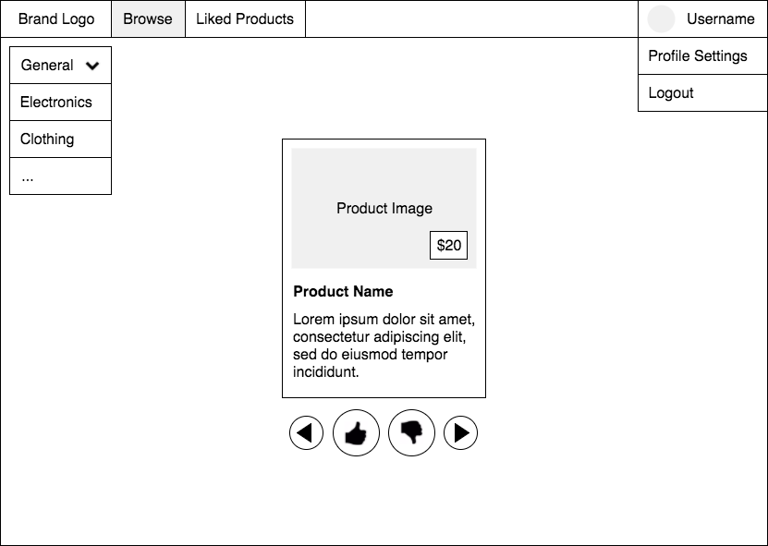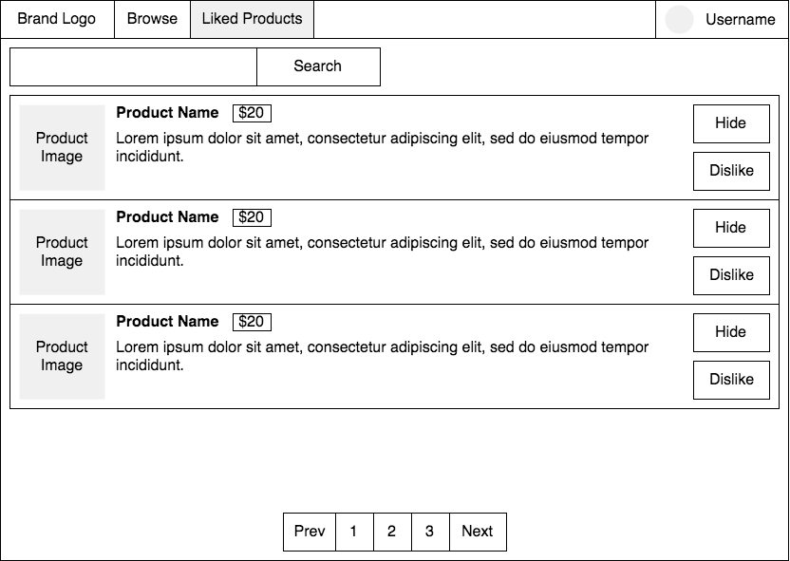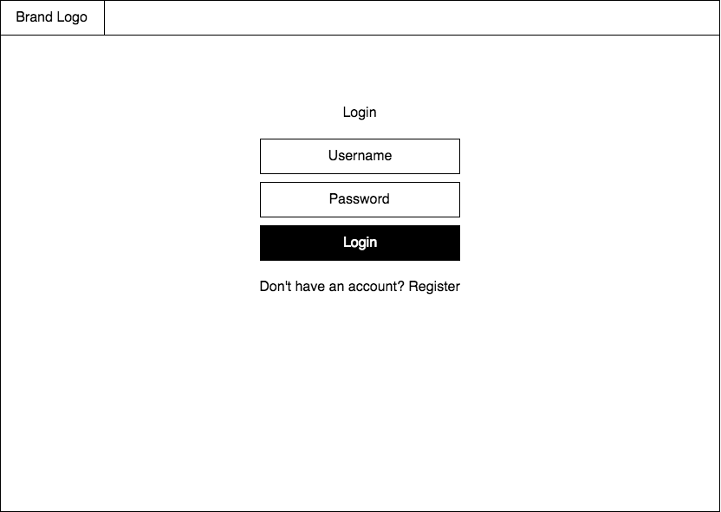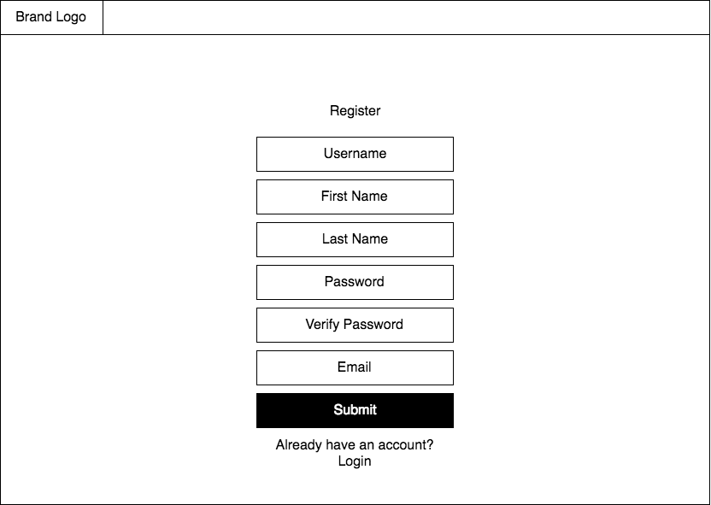

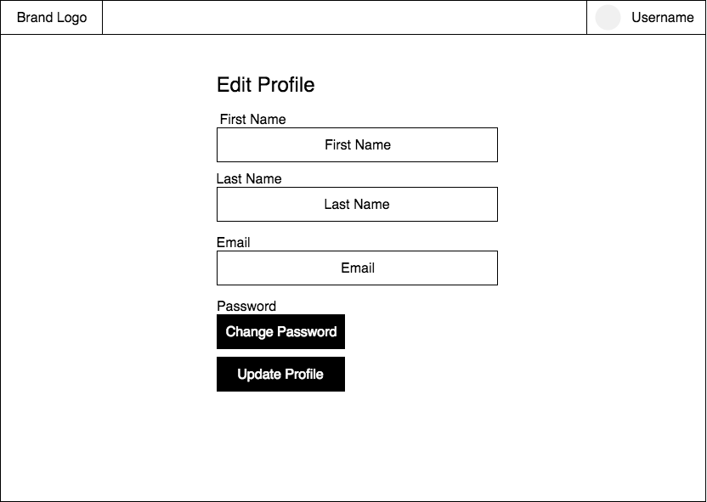

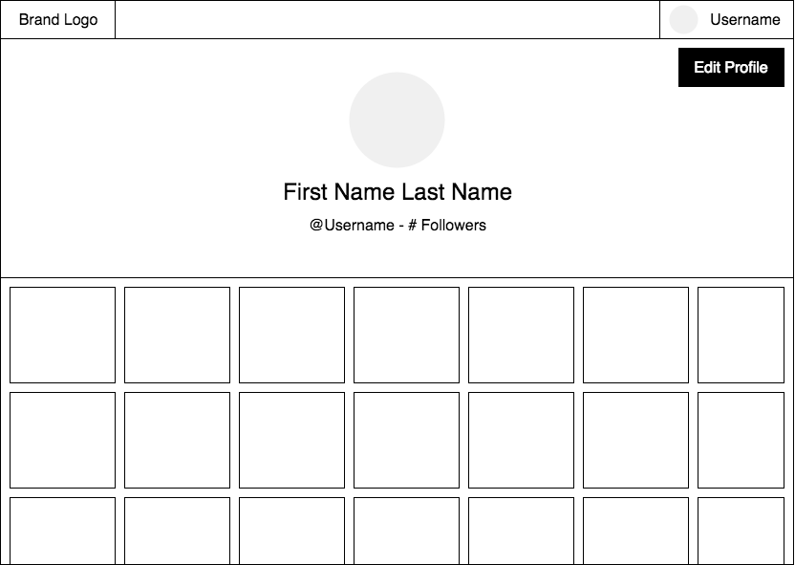

1. **Functional Requirements Specification** 
   1. **Stakeholders**
      1. Shoppers
         1. Consumers who have the goal of browsing for products would be our main customer. Therefore, they become a stakeholder in this style of product. If we cannot supply a product that our target market likes, we would not be able to sustain business. In addition, if the product does not satisfy the user, the retailers would not want to advertises or supply their products to our website. The consumer is the most important stakeholder.
      2. Advertisers/Retailers
         1. When consumers are constantly inputting their preferences, advertising can be custom made to fit these preferences. Furthermore, this increases the likelihood that the customer will buy the product being advertised. This is why retailers and advertisers would be prime stakeholders for our application. If we can please our users and entice them to continue to use our product, the retailers and advertisers will be satisfied with the service we can provide for them.
   2. **Actors and Goals**
      1. **Actors**
         1. Shopper
            1. Shoppers can give input to our application in a handful of different ways, they can like or dislike a product, or they can associate their preferences with their profile. When they like a product, it will be associated with their profile and be added to their liked products page.
      2. **Goals**
         1. Shopper
            1. The goal for the Shopper is to browse through suggested products. While browsing, Shoppers can like or dislike products to improve the suggestions being made. Shoppers can subscribe to new channels to have their suggestions be tailored to that type of product or brand. The overall goal is for Shoppers to be exposed to a variety of products that are tailored to their preferences in a central location, with an easy to use interface.
         2. Advertisers
            1. Another goal for our website is to provide a better way for companies and businesses to advertise their products. Instead of annoying advertisements bombarding users of other websites, our website allows for Shoppers to be exposed to products. Companies can pay to have their products be promoted within channels and on the homepage of the app to users who may be highly likely to like their products based on the input they have provided to our algorithm.
   3. **User stories, scenarios and Use Cases**
      1. **User Stories**
         1. As a user, I can register for a profile so I can have a profile.
         2. As a Shopper, I can verify my email so I can log into my profile.
         3. As a Shopper, I can sign into my profile so I can access the website.
         4. As a Shopper, I can sign out of my profile so my account is protected.
         5. As a Shopper, I can edit my profile so I can edit my personal information.
         6. As a Shopper, I can reset my password so I can access my account if I forgot my password.
         7. As a Shopper, I can change my email so I can access my account with a new email.
         8. As a Shopper, I can change my password so I can protect my account.
         9. As a Shopper, I can open a channel so I can browse through suggested products.
         10. As a Shopper, I can skip a product so I can get a new suggestion.
         11. As a Shopper, I can view my profile so I can see my profile information.
         12. As a Shopper, I can view the home page so I can view the channels panel and channel view.
         13. As a Shopper, I can see a photo of the present product so I can see if I like it.
         14. As a Shopper, I can enter my preferences on the onboarding screen so I can receive better suggested products.
         15. As a Shopper, I can like a product so I can see it later and update my preferences.
         16. As a Shopper, I can dislike a product so I can update my preferences.
         17. As a Shopper, I can view the liked products page so I can see the products I have liked.
         18. As a Shopper, I can unsubscribe from a channel so I will no longer see that channel.
         19. As a Shopper, I can follow another Shopper so I can see their profile.
         20. As a Shopper, I can go back to a previous product in the channel so I can change my input on it.
         21. As a Shopper, I can search for a new channel so I can subscribe to channels.
         22. As a Shopper, I can view more information on a product so I can see if I want to buy the product.
         23. As a Shopper, I can search for other Shoppers to follow so I can see what products they like.
         24. As a Shopper, I can review the channels I have subscribed to so I can see the categories of products I have subscribed to.
         25. As a Shopper, I can review the Shoppers I have followed so I can managed the Shoppers I can see.
         26. As a Shopper, I can view the following channel.
         27. As a Shopper, I can view the top 10 trending products on the homepage.
         28. As a Shopper, I can view more information on a product.
      2. **Scenarios**
         1. Login page loaded
            1. Clicks the register link

User clicks submit

User did not enter valid information

Error message is displayed with missing fields highlighted

User entered required information and is logged in under submitted email and password

Credentials are saved to database and a verification email is sent to the user

The user clicks the link

The user’s account is now verified in the database and they are taken to the login page.

The user never clicks the link

The user’s account is not verified in the database and they cannot login

* + - * 1. Clicks login button

User did not enter a valid email

Error message is displayed saying that the entered email was not found

User did not enter the password associated with the entered email

Error message is displayed saying that the entered password is not correct

User entered a valid email and the password associated with the entered email.

User is now logged in as a Shopper with their profile information

User attempts to login five times incorrectly

Account is locked for 10 minutes

* + - * 1. Clicks forgot password link

The forgot password page is shown, the user clicks submit

The user entered an invalid email

A message is shown “Email not found”

The user entered a valid email

A verification email is sent

The user clicks the link

The user’s email is now verified and saved to the database

The user never clicks the link

The user’s email is not verified and not changes are made to the database

* + - 1. Once logged in, the Shopper is on any page
         1. The Shopper clicks the logout button

The Shopper now becomes a user and is returned to the login page

* + - 1. Once logged in, the Shopper is on the profile page
         1. Shopper clicks edit profile

The edit profile page is shown, the Shopper clicks cancel

No changes are made to the information in the database and the Shopper returns to the profile page

The edit profile page is shown, the Shopper edits the information shown and clicks submit

The changes made to the information is reflected in the database and the Shopper is returned to the profile page

The edit profile page is shown, the Shopper clicks change email

The change email page is shown, the Shopper clicks submit

The user did not enter a valid email

An error message is shown saying “The email entered was invalid”

The user entered a valid email and a valid password

A verification email is sent

The user clicks the link

The user’s new email is now verified in the database and they are taken to the login page and the new email is saved to the database.

The user never clicks the link

The user’s email is not verified in the database and the previous email is not changed.

The user entered a valid email and an invalid password

An error message is shown saying “The email or password entered was invalid”

The user entered an invalid email and an invalid password

An error message is shown saying “The email or password entered was invalid”

The edit profile page is shown, the Shopper clicks change password

The change password page is shown, the Shopper clicks submit

The user did not enter a valid password

An error message is shown saying “The password entered was invalid”

The user entered a valid password, a matching confirm password and a valid previous password

A verification email is sent

The password is updated in the database.

The user entered a valid password, a matching confirm password and a invalid previous password

An error message is shown saying “The current password entered was invalid”

The user entered a valid password, a not matching confirm password and a valid previous password

An error message is shown saying “The password and confirm password do not match”

* + - * 1. The Shopper clicks the Following tab

A list of the Shopper’s that are being followed by that Shopper are shown

The Shopper clicks a Shopper

The Shopper’s profile is shown

* + - * 1. The Shopper clicks the Channels tab

A list of the channels are shown that the Shopper subscribes to

The Shopper clicks on a channel

The Shopper is taken to the channel view for that channel

* + - * 1. The Shopper clicks the Likes tab

A list of products that have been liked by the Shopper are shown

The Shopper clicks on one of the shown products

The more information page is shown for the selected product

The Shopper searches for a product in the search bar

A list of products that have a similar name or tags to the search word are shown.

The Shopper hovers over one of the products and clicks the thumbs up button

The product is now added to that user’s likes page

The Shopper hovers over one of the products and clicks the thumbs down button

The product is now added to that user’s dislikes table

* + - 1. Once logged in, the Shopper is in the Channel view
         1. A product is shown, the Shopper clicks like

The product is added to the Shopper’s liked products page and a new product is shown to the Shopper

* + - * 1. A product is shown, the Shopper clicks dislike

The product is added to the disliked products table for the Shopper and a new product is shown to the Shopper

* + - * 1. A product is shown, the Shopper clicks skip

No input is associated with the product and a new product is shown to the Shopper

* + - * 1. A product is shown, the Shopper clicks more information

The more information page is shown to the Shopper for the shown product

* + - * 1. A product is shown, the Shopper clicks the previous product arrow

The previous product is shown with the associated input from before

* + - 1. Once logged in, the Shopper is on their profile page
         1. Rows of pictures are shown of liked products of that Shopper

These pictures can be seen when other Shoppers look on another Shopper’s profile.

* + - 1. Once logged in, the Shopper is on the Home page
         1. Shopper searches for a channel

A list of suggested channels are shown. The Shopper clicks on one of the choices

The Shopper clicks on the subscribe button

The channel is added the channels panel and the Channels tab within the Shopper’s profile

* + - * 1. Shopper clicks on a channel

The channel is shown and Shopper clicks unsubscribe

The channel is removed from the Shopper’s channels tab and the channels panel

* + - * 1. Shopper clicks on one of the shown channels in the Channels Panel

The Shopper is taken to the Channel view for that channel

* + - * 1. Shopper searches for a Shopper

A list of suggested Shoppers are shown. The Shopper clicks on one of the choices

The Shopper clicks on the follow button

The Shopper is added the Shoppers’ panel and the Following tab within the Shopper’s profile

* + - * 1. Shopper clicks on a Shopper’s username

The Shopper’s profile is shown and Shopper clicks unsubscribe

The Shopper is removed from the Shopper’s Following tab and the Shoppers’ panel

* + - * 1. Shopper clicks on one of the shown usernames in the Shoppers’ Panel

The Shopper is taken to the Shopper’s profile

* + - * 1. Shopper clicks on the general channel

The Shopper will now be suggested products from any channel that they may like

* + - 1. Once logged in, the Shopper viewing a product
         1. The Shopper clicks on the product

Information such as product name, manufacturer, URL to buy the product, and a description of the product are show

* + - 1. The Shopper accesses the website via a mobile device
         1. All pages are shown in the mobile friendly version to accommodate to the smaller screen size